**on march 3**

**Task on CDN,R53.**

1. Configure VPC peering in cross regions

Step a) created vpc and subnet and RT and attached internetgateway.

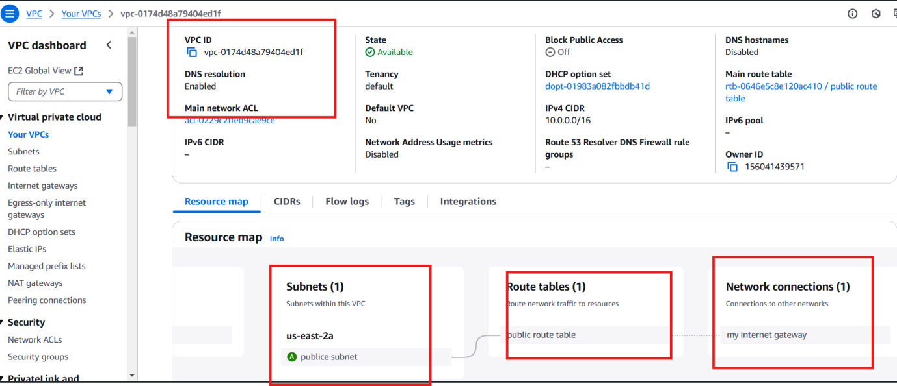

Stepb) creared ec2 in ohio region and attached own vpc

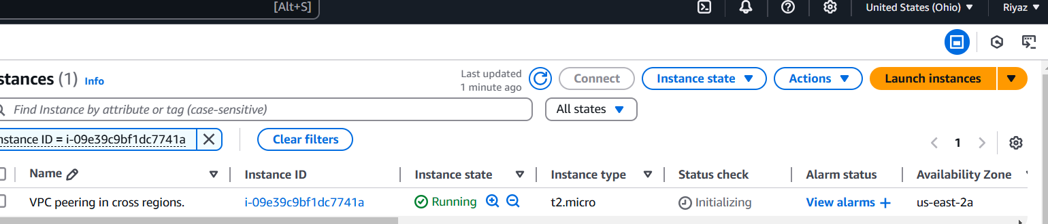

Step c) 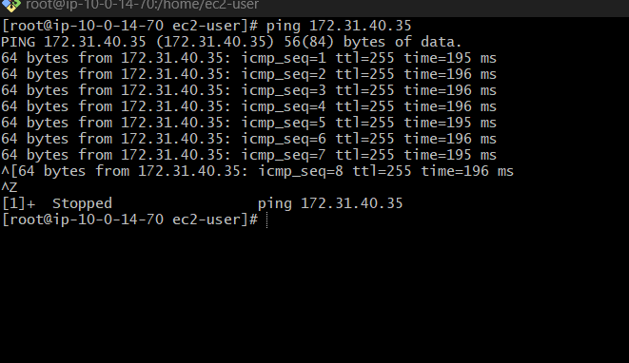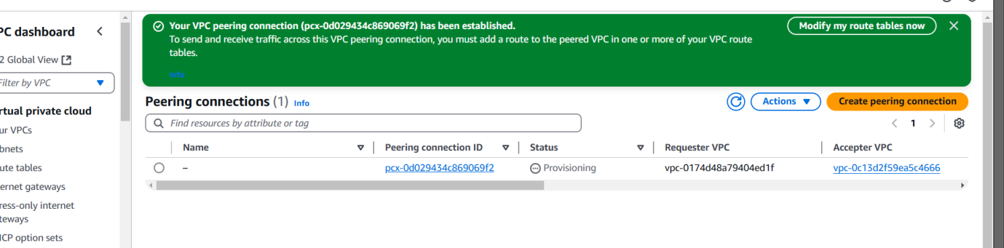

2) Purchase one domain from GoDaddy.

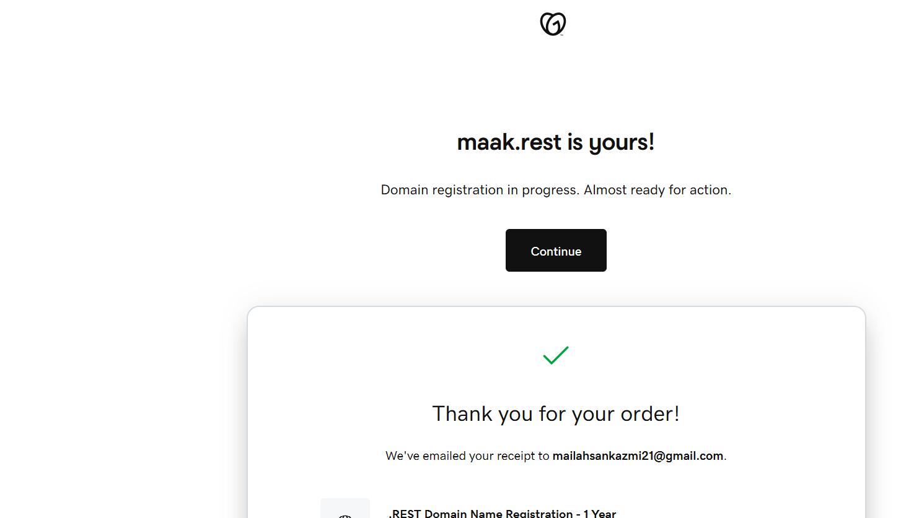

Route 53 configured succfully

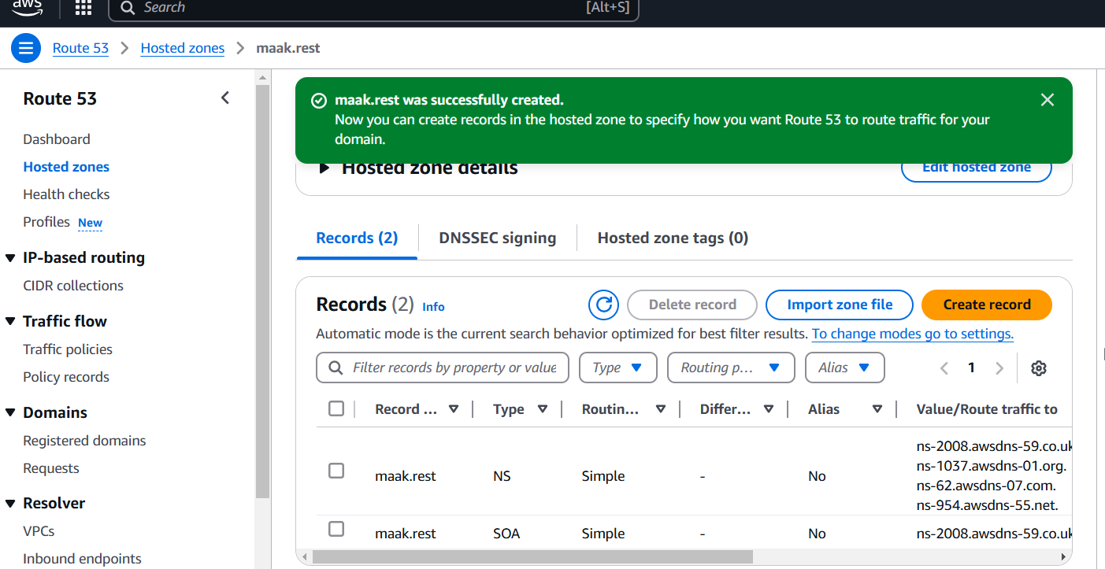

Successfully configured the name server now in go dadday

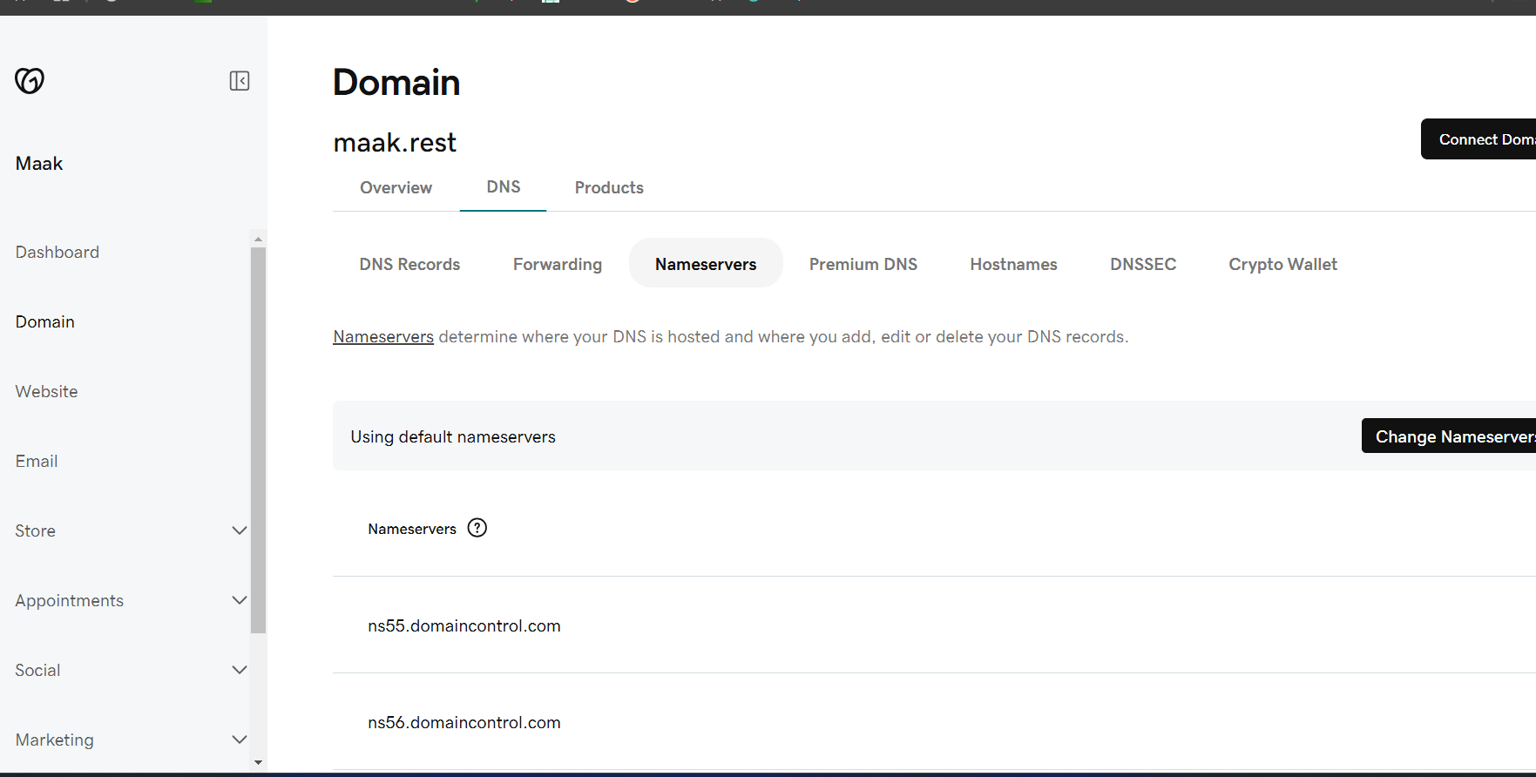

Created a s3 bucket name maak.rest as same name domain name

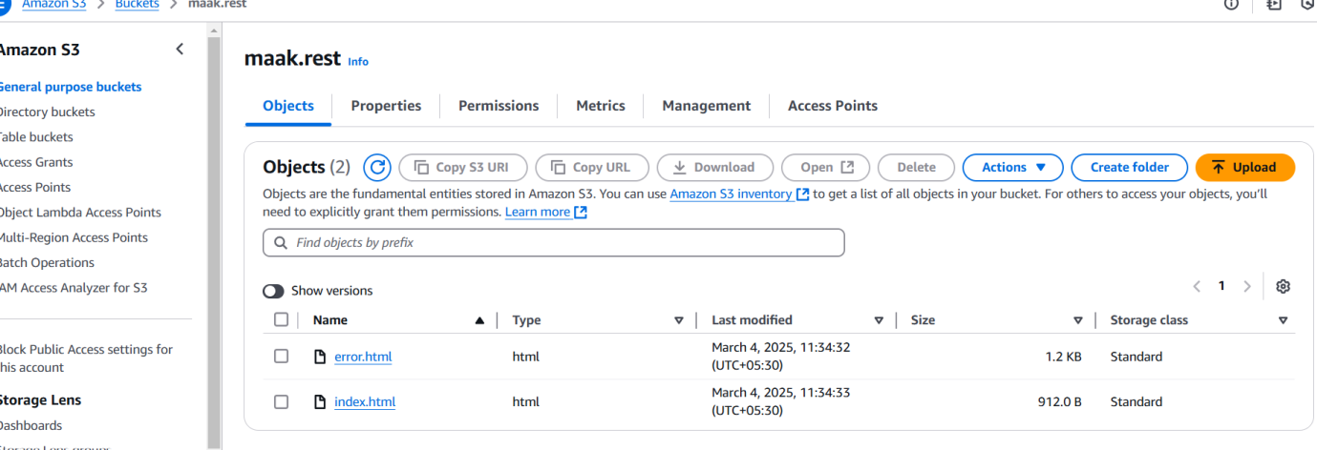

3) Deploy static website in s3.

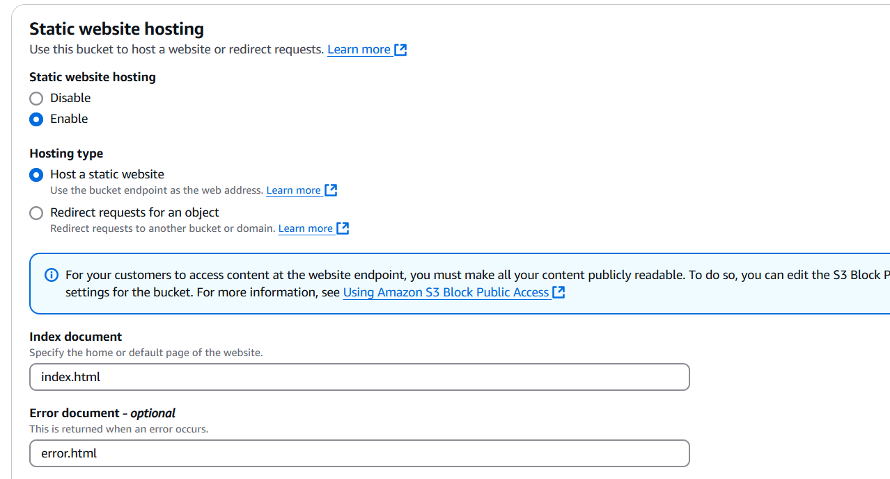

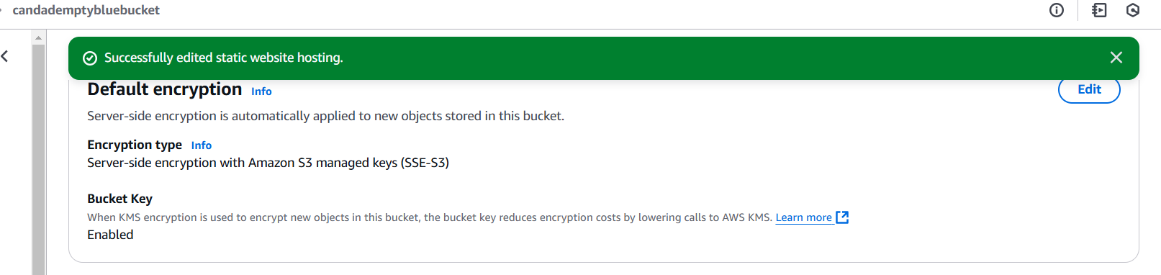

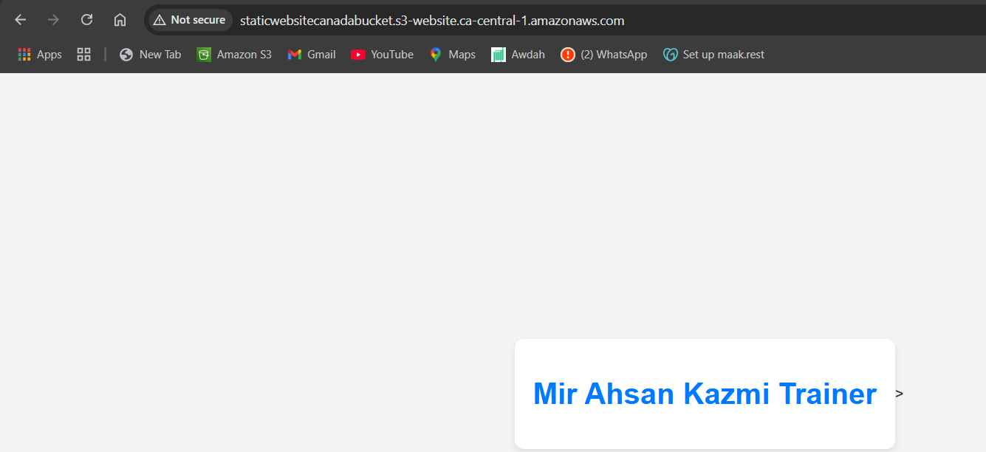

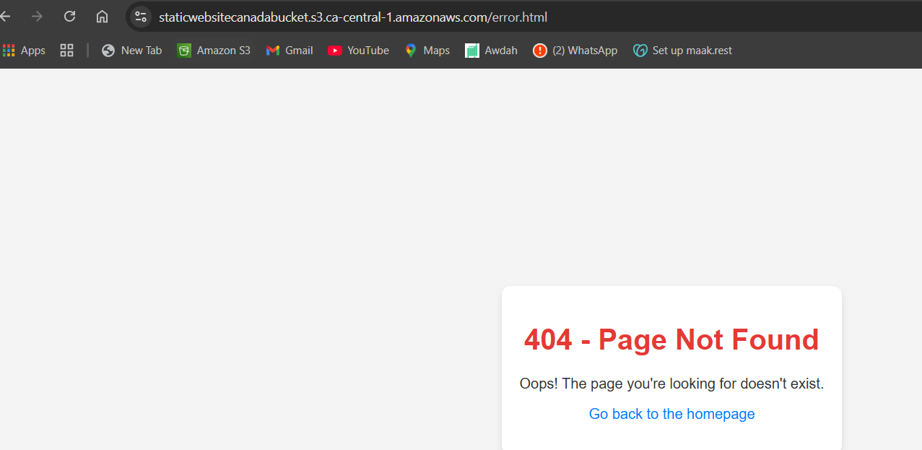

Now created cloud front distribution

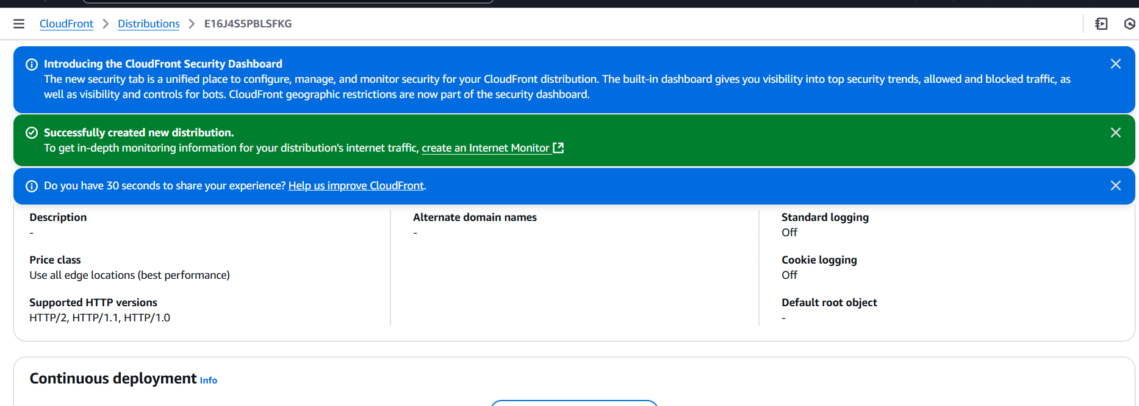

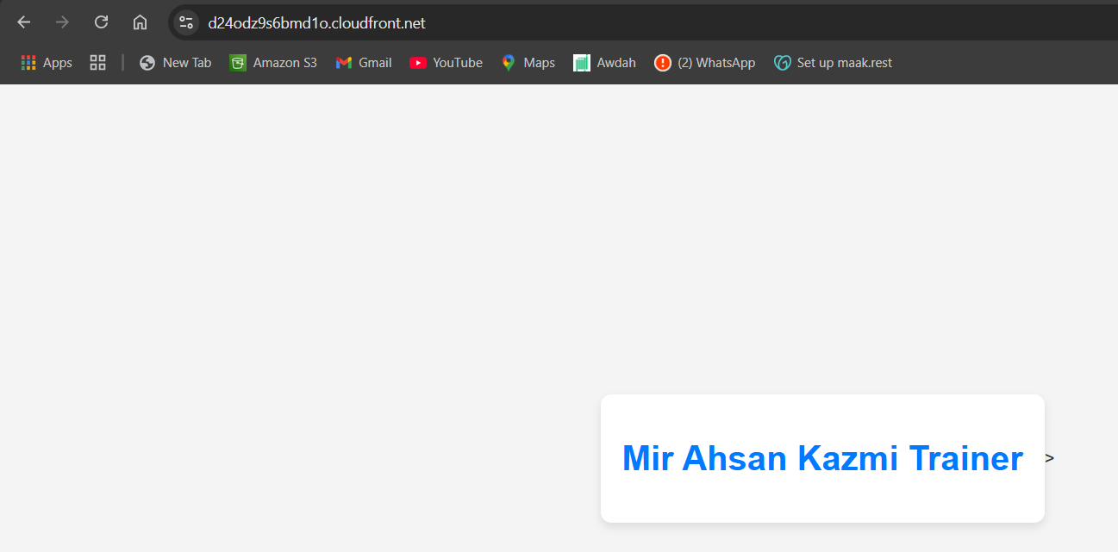

Reuest a ssl certificate from cloud front

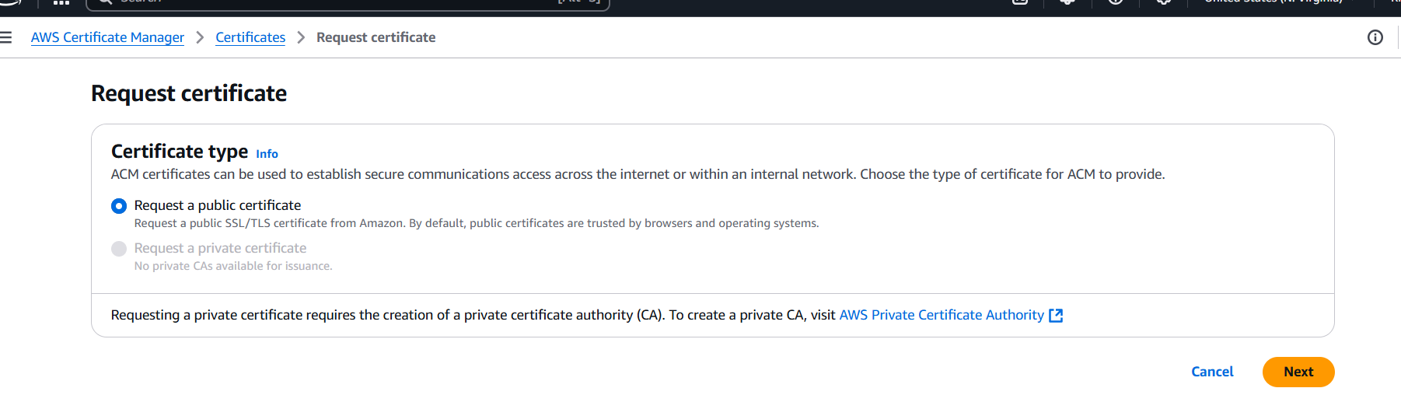

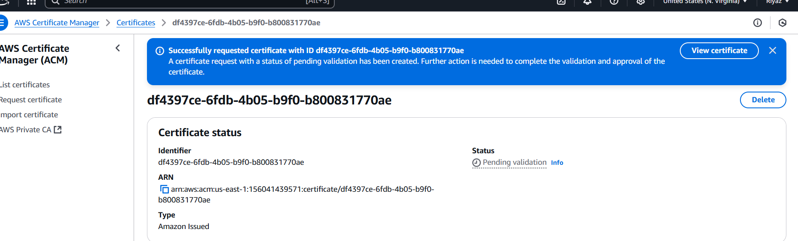

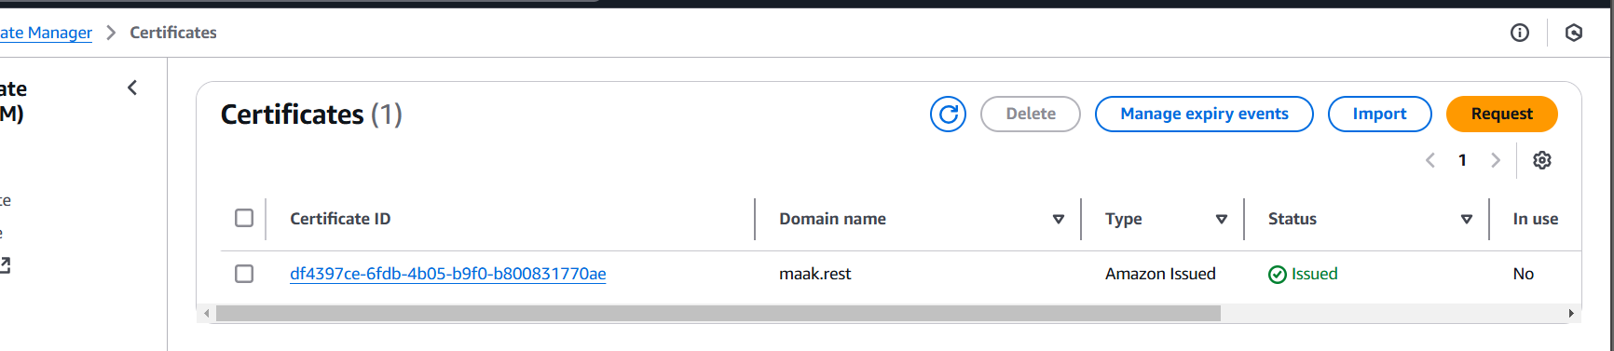now using https can easily accces domain

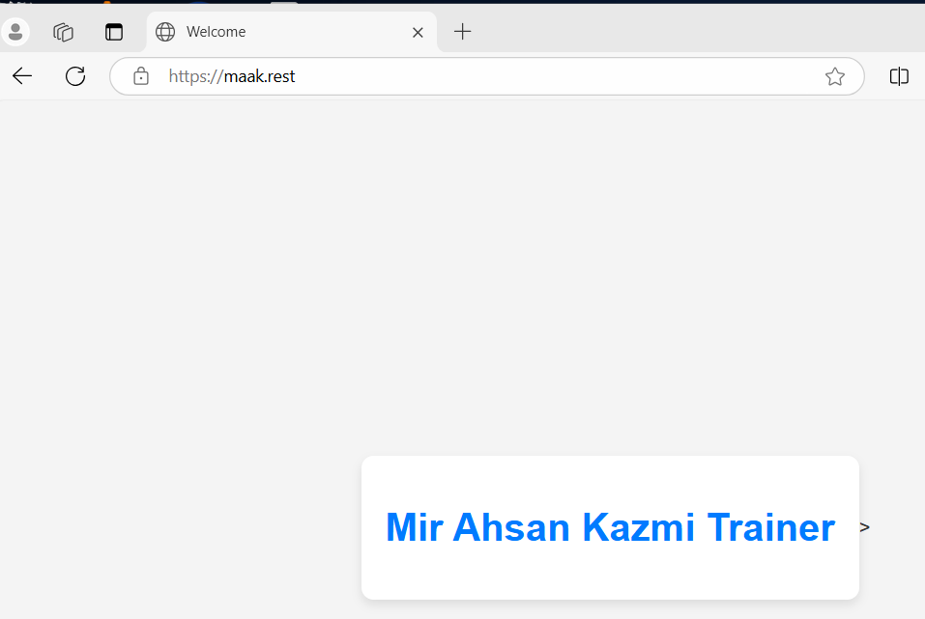

4) Create CDN and attach one SSL certificate.

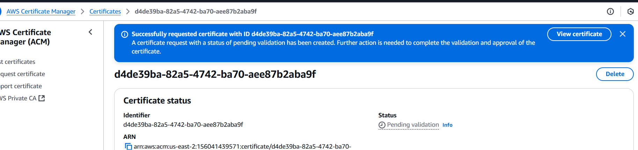

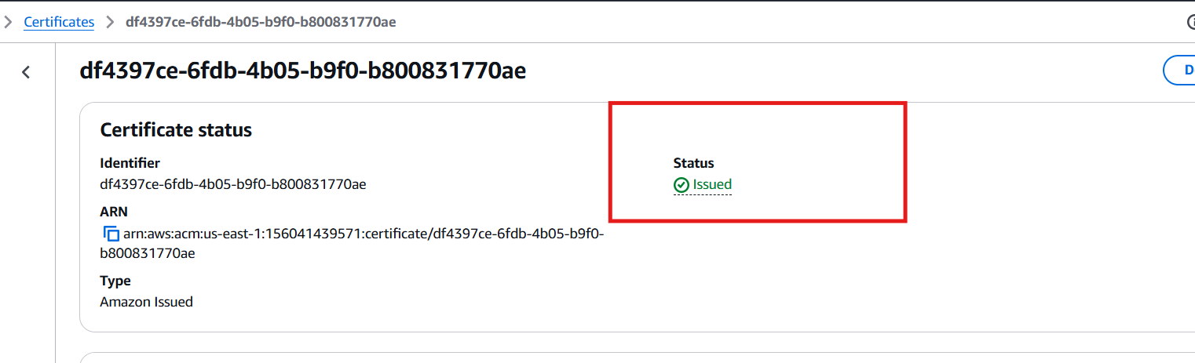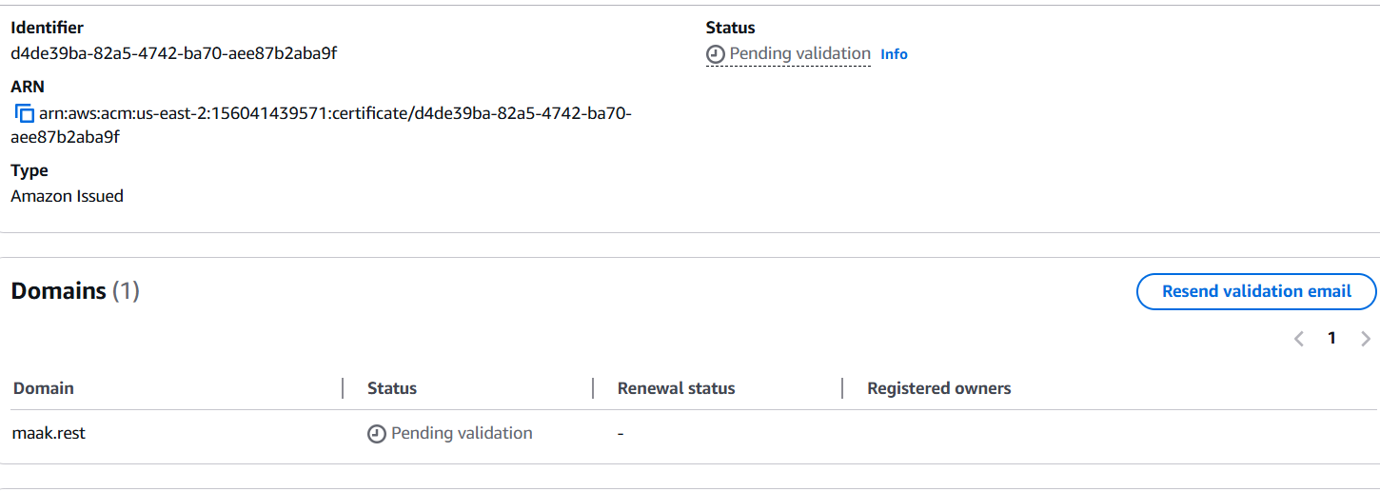

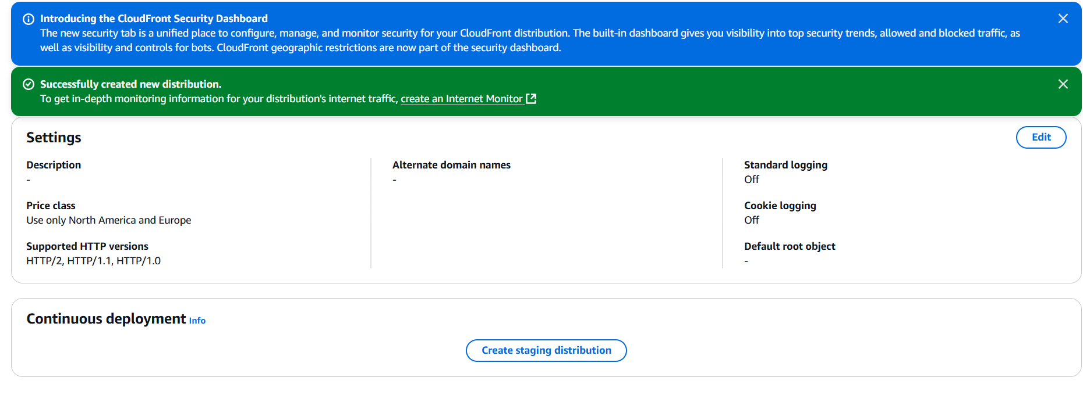

Created distribution setting

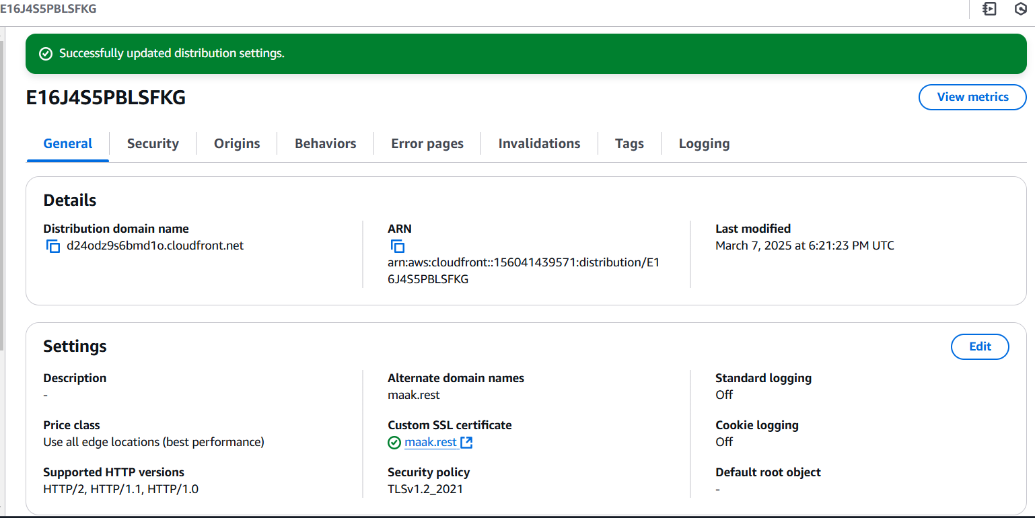

5) Create Route53 hosted zone and MAP the domain with CDN.

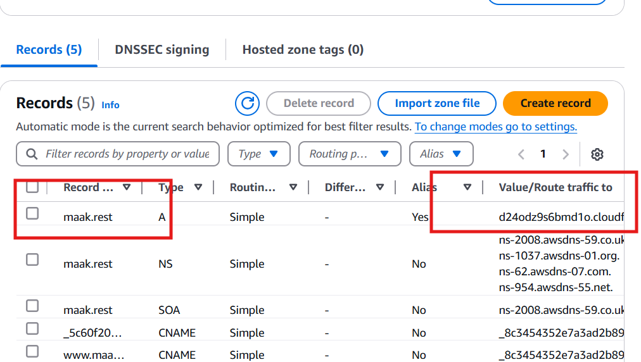

7) Share the Domain name in slack to test the connectivity

